<University, College name> <Name of the faculty>
Project plan
<Race number>
<Team name>
XII. International Aventics Pneumobile Competition 2019 – powered by Emerson

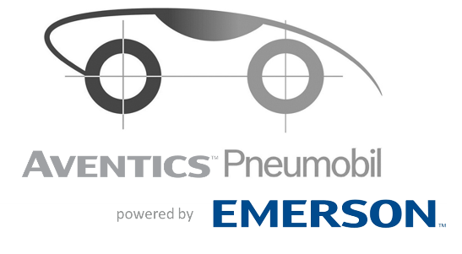

Content
1. Short introduction of the project 3
2. Project organization 3
3. Planned budget of the vehicle 3
4. Time plan of the project 3

Short introduction of the project

Project organization

Planned budget of the vehicle

Time plan of the project

